**Clauses, Joins and Subqueries**

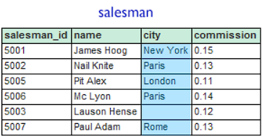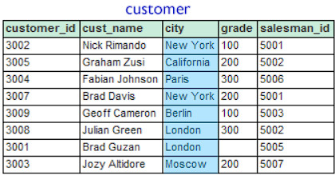

ORDERS

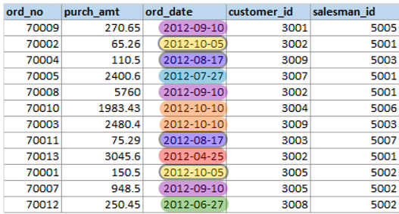

Refer the datasets given above to answer the following questions:

1. From the following tables write a SQL query to find the *salesperson(s)* and the *customer(s)* he represents. Return *Customer Name*, *city*, *Salesman*, *commission*.
2. From the following tables write a SQL query to display the *customer name*, *customer city*, *grade*, *salesman*, *salesman city*. The results should be sorted by **ascending** *customer_id*.
3. From the following tables write a SQL query to locate those salespeople who do not live in the same city where their customers live and have received a commission of more than 12% from the company. Return Customer Name, customer city, Salesman, salesman city, commission.
4. From the following tables write a SQL query to count the number of customers with grades above the average in New York City. Return grade and count.
5. Write a query to find the sums of the amounts from the **orders table**, grouped by date, and eliminate all dates where the sum was not at least 1000.00 above the maximum order amount for that date.
6. From the following tables write a SQL query to find the salespeople who deal with customers with more than one order. Return salesman_id, name, city and commission.
7. Refer the following table for the dataset: [SQL Week 2 dataset](https://docs.google.com/spreadsheets/d/1pFA6B656WdfdYLl1OHRwv2adE6hLSeLTFN30K8gHxwM/edit?usp=sharing)  
   Get a list of **cust_city**, *sum* of **opening_amt**, *average* of **receive_amt** and *maximum* **payment_amt** from customer table with following conditions-

a. Grade of customer table must be 2

b. *Average* of **receive_amt** for each group of **cust_city** must be more than *500*

1. From the table “orders”, arrange the entries in ascending order of their **ord_no**. Then return all the entries which have **purch_amt** > Rs. 500.